Main Bird-Watching Localities

The following text is taken from the latest version of the booklet 'The Birds of Islay' by Malcolm Ogilvie. The third enlarged and fully revised edition of this popular guide, which first appeared in 1992, was published in 2003. Expanded to 80 pages, it contains a complete systematic list of all 277 species and five identifiable subspecies seen on the island to the end of 2002. Status information for each species includes the most important areas and times of year, as well as an indication of numbers present, whether breeding, passage or wintering. Introductory chapters describe the different habitats on the island together with the top ten bird-watching locations. As a new feature, the booklet includes checklists of mammals, reptiles and amphibians, butterflies, dragonflies and wild flowers.
The booklet is currently out of print with a new edition in preparation. On publication, details will be posted here.

There are almost no areas of Islay where there isn't good birdwatching, but I have picked out ten top sites and set them out in some detail with particular attention to good stopping places and the typical birds.
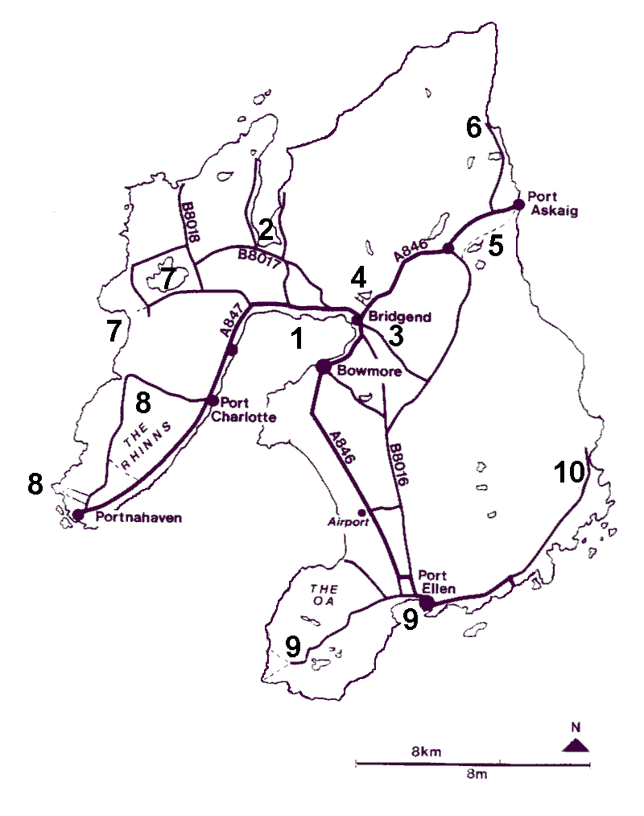
Click on the numbered dots for detailed information

1. Loch Indaal - Bowmore to Port Charlotte (NR3160 to NR5825)
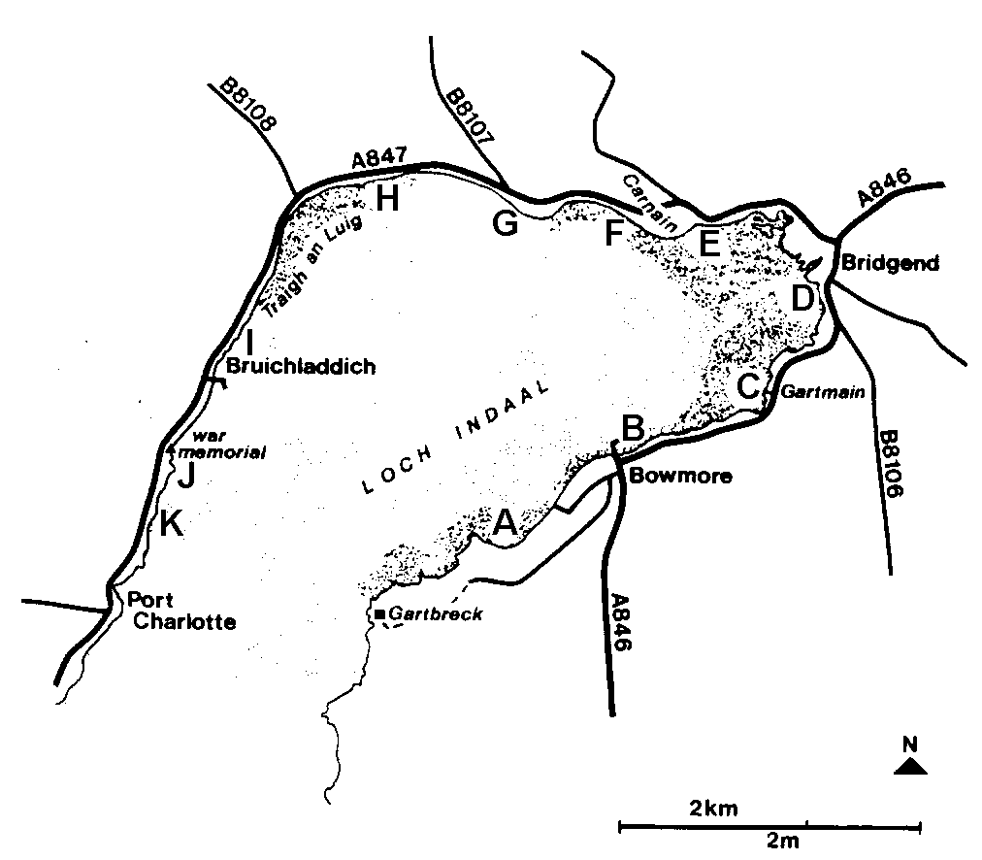
Click on the lettered dots for more information

Loch Indaal offers excellent viewing for the birdwatcher in a car as well as easy walking. The following places are keyed with letters on the map and mostly allow a car to park off the road, including at some specially provided birdwatching lay-bys. BE VERY CAREFUL if stopping elsewhere, the road is full of blind bends. Obviously the state of the tide is important as, when it is right out, waders in particular can be a long way off. At high tide, they often roost on the edge of the saltmarsh. However, this only applies to the head of the loch as the shores either side of Bowmore and from Glenburn to Bruichladdich are equally good regardless of the tide. The seaducks and other birds on the water seem little affected by the tide state.
A. Bowmore south to Gartbreck (NR3160-NR2858)
This stretch can be overlooked from the unclassified lane that runs south out of Bowmore to the council rubbish tip, but only at a distance. A track leads from beside the school playing fields down to the shore and one can then walk south to Gartbreck. There is also access to the shore down tracks beside Ronnachmore and Ardlarach, and along the track that continues on from the entrance to the tip.
Typical species: winter geese in the fields; gulls, including Glaucous and Iceland, as well as large numbers of Ravens, at the tip; Shelduck, Wigeon, Mallard, Oystercatcher, Ringed Plover between the islets and the shore; Shag, Eider and Common Seals on and around the islets.
B. Bowmore Pier to Generating Station (NR310610-NR320602)
There are three good viewing places long this stretch of coast: Bowmore Pier; the lay-by immediately after the last house on the left leaving the village; and the large pull-off opposite the electricity generating station. This last is especially good because elevated.
Typical species: Scaup flock and other seaducks (Common Scoter, Goldeneye, Long-tailed), divers and Slavonian Grebes; swans and Wigeon just offshore usually to the right of the generating station; Purple Sandpiper, Turnstone on rocks near the pier.
C. Gartmain (NR 328607)
An obvious pull-off by a small bridge and opposite two bungalows. It overlooks a small burn flowing out through a promontory as well as extensive sandflats.
Typical species: swans, geese, ducks, waders and gulls all come to bathe, drink and roost. At low tide, ducks and waders will be feeding out towards the tide edge.
D. Bridgend Merse (NR330612-NR323627)
The road now wriggles round the head of the loch. There is a pull-off on the left on a sharp right-hand bend, just after a small cottage above the road on the right. It is quite easy to turn into coming from Bowmore, but harder to get out of because of poor visibility. Although grassed over, it has a hard surface underneath. From here, scan the channel of the River Sorn as it runs out through the sandflats; a telescope is helpful. A high tide roost of waders is situated on the small saltmarsh islets to the left. Barnacle Geese sometimes feed on the saltmarsh very close in to the road.
Typical species: swans, Wigeon, Teal, Mallard, Pintail, Shoveler, Oystercatcher, Ringed Plover, Golden Plover, Grey Plover, Dunlin, Bar-tailed Godwit, Curlew. Barnacle Geese on the merse; Grey Heron on merse and on islands beside river channel.
E. Carnain (NR319628)
At Bridgend, turn left on to the A847 towards Bruichladdich. The road runs alongside the merse, and, shortly after a small bridge, there is a birdwatching lay-by on the left. This gives good views over the merse as well as distant views of the sandflats. A little further on, as the road swings sharp right round a large outcrop, turn off left at the end of the wall on the left-hand side. This track leads to two cottages so do not block it. There is a muddy tidal pool here as well as a view over the sandflats. Back on the road there is a rushy pool on the left opposite the next two cottages, which is good for dabbling ducks and breeding Redshank.
Typical species: Grey Heron, Shelduck, Teal, Pintail, Oystercatcher, Ringed Plover, Dunlin, Bar-tailed Godwit, Curlew, Redshank, Grey Heron; Barnacle Geese on the nearby grassland.
F. Glenburn (NR308620)
The road now runs across unfenced grassland, which undulates over the underlying pebble ridges formed as a succession of beaches when the land gradually rose several thousand years ago. This area is much used by Barnacle Geese in winter and nesting Lapwing and Redshank in spring and summer. The road then descends to a sandy beach and crosses a burn. A birdwatching layby has been constructed on the left just past the bridge over the burn.
Typical species: Scaup flock often close in, with Slavonian Grebe, while Wigeon, Eider; Oystercatcher, Dunlin, Bar-tailed Godwit roost at high tide.
G. Blackrock (NR305626)
At the end of the small bay the road climbs over a rocky promontory. A parking area large enough for several cars has been created on the left on the crown of the hill. From here one overlooks the offshore Blackrock and the sea to either side. There is a gate in the fence to allow walking down closer to the shore to get a better view of Blackrock and the sea to the right, which is a good area for divers and seaducks.
Typical species: Common and Arctic Terns nesting on Blackrock; Shag and Cormorant perched on it; Slavonian Grebe, Scaup, Eider, Common Scoter, Red-breasted Merganser offshore.
H. Traigh an Luig strand (NR298630-NR275630)
The road runs alongside the shore for the next two miles (c.3 km) of a sweeping sandy beach backed by shingle and an extensive area of unfenced grassland. The steep-sided ridge at the back of the grassland is the outwash from a glacial river, cut into by the sea when the sea level was much higher than it is now. It is possible to pull off on to the grass at several points along the road. Probably the best place is about two-thirds of the way along the beach where a shingle spit sticks out. Arctic Terns nest most years close to the base of the spit as well as at different places along the beach. If you see them there, please stay at a safe distance, both to stop being dive-bombed and to avoid the risk of treading on their extremely well camouflaged eggs and young.
Typical species: Oystercatcher, Ringed Plover, Dunlin, Sanderling, Bar-tailed Godwit, Curlew; Turnstone on spit and intertidal zone, especially on rotting seaweed; Eider and divers offshore; Curlew, Greenland Whitefronts and Chough on the grass; Ravens and Buzzards soaring along the ridge.
I. Bruichladdich (NR2661)
After Traigh an Luig, the road becomes very bendy with few stopping places, but also fewer birds until Bruichladdich. Opposite the first group of four bungalows and two houses are extensive tidal rocks with a convenient lay-by by the second house. There are large pull-offs on the shore side opposite the village shop and the distillery. It is also possible to walk out onto the pier.
Typical species: Shag, Wigeon, Eider, Ringed Plover; Purple Sandpiper along the shore; Turnstone on rocks opposite shop and distillery; all three divers and Common Scoter from pier.
J. Port Bhan War Memorial (NR260602)
This is on the shore side half a mile towards Port Charlotte. There is a pull-off on the right-hand side of the road. A telescope is useful here either from the car or when standing beside the war memorial. The fields either side of the road are a regular location for Whimbrel in the late spring, while they also hold a substantial population of Brown Hares (40 in a single field being quite usual).
Typical species: all three divers, Common Scoter all year; Manx Shearwater, Gannet, flocks of Guillemot and Razorbill in summer.
K. Port Bhan to Port Charlotte (NR260602-NR2558)
It is possible to stop along this road and see the same species as at Port Bhan though not usually as easily. Port Charlotte village houses the Wildlife Information Centre, clearly marked on the left just over the narrow bridge as you enter the village. Information and displays relating to all aspects of wildlife are housed here and your own records are especially welcome as contributions to our knowledge of the island's birds and other wildlife and for inclusion in the annual bird and natural history report.
Return to top
2. Loch Gruinart - including RSPB Reserve, Gruinart Flats, Ardnave and Killinallan
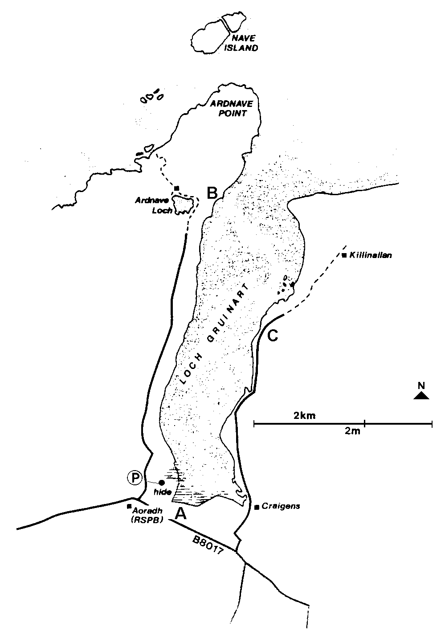
Click on the lettered dots for more information

The greater part of the inner half of Loch Gruinart and three-quarters of the Gruinart Flats (the pastures to the south of the loch) are part of the RSPB?s Loch Gruinart reserve. Please, therefore, keep to the roads in this area and do not wander over the fields. Two of the principal aims of the reserve are to provide safe and undisturbed feeding for the wintering geese and ideal conditions for breeding waders and ducks, as well as to show these to the many visitors to the reserve, all of which can only be achieved with the minimum of disturbance. The loch virtually empties at low tide and the ducks and waders feeding on the mud become very spread out and not easy to see. At high tide, the small island in the middle is an important roost.
A. Gruinart Flats and RSPB Reserve (middle roughly at NR2867)
A road (the B8017) runs right across the Flats. It is single track but with ample large lay-bys which enable one to get superb views of the wintering geese in the fields on either side. In spring and summer the fields are full of nesting waders. The best goose viewing is from a car. Resist the temptation to get out ? it only flushes the nearer geese and sometimes all of them, which spoils it for you and any other birdwatchers there. At the western end of the road is the RSPB?s visitor centre and farm, Aoradh. The centre contains an exhibition explaining the importance of the reserve and has a fine viewing gallery looking out over the fields. A large hide is situated overlooking the bunded and flooded fields to the north of the farm, reached from the lane opposite the farm entrance, signposted Ardnave. There is a small carpark opposite the path to the hide while a woodland walk runs north from here for over half a mile (1 km). There are regular walks conducted on the reserve, as well as other events depending on the time of year. Call at the Reserve or check posters in hotels and the Tourist Office for details.
Typical species: Barnacle and Greenland White-fronted Geese, plus occasional Brent, Canada, Pinkfoot; Lapwing, Snipe, Redshank, Skylark breeding; Hen Harrier, Buzzard, Peregrine, Golden Eagle hunting through area; Whooper Swans in autumn. Wigeon, Teal, Pintail, Shoveler, Lapwing, Redshank, Black-headed Gulls, Snipe in the flooded fields; Chough around the derelict buildings; Corncrake in ungrazed fields and nettlebeds.
B. Ardnave Loch and Peninsula (NR2872 north to NR2974)
The lane past the hide continues for about three miles (c.5 km) before becoming a track beside Ardnave Loch. The fields on either side of the lane contain geese in winter, but views of Gruinart Loch are distant, although closer, and elevated, views can be had from beside the historic Kilnave Chapel, which is signposted on the right about three-quarters of the way along. Ardnave Loch, one of the most fertile on the island often holds swans as well as a wide variety of ducks and some waders. Walk from the loch through the dunes and down to the shore of Loch Gruinart. From here one can overlook a muddy bay to the right or walk left along the shore. It is possible to walk right round the peninsula and back to Ardnave Loch via a farm track which reaches the west shore. The farmer here is managing the land for birds in conjunction with the RSPB. Part of that management includes controlled grazing of different areas to encourage both Chough and Corncrake, so it is vital that gates are kept closed. In order to alleviate past problems with this, a number of 'kissing' gates have been installed to remove the need for walkers to open the big ones.
Typical species: Little Grebe, Whooper Swan, Mute Swan, Wigeon, Teal, Mallard, Tufted, Goldeneye on Ardnave Loch, also Lapwing, Redshank, Snipe, all of which breed in the wet areas throughout the peninsula; divers, Wigeon, Red-breasted Merganser, Oystercatcher, Curlew on Loch Gruinart; Arctic Tern fishing in channels; Chough, Twite, Snow Bunting among dunes, particularly where cattle are fed in winter; Barnacle Geese on pastures; Ringed Plover, Sanderling, Snow Bunting on shore of peninsula; Great Northern Diver between Ardnave Point and Nave Island. Both Gruinart and Ardnave Lochs are frequented by Otters.
C. East side Loch Gruinart, Craigens to Killinallan (NR2967 north to NR3072)
On the far side of the Gruinart Flats from the RSPB farm, there is a turning to the left if one is coming from the farm, or to the right if coming from Bridgend. This lane runs up the east side of Loch Gruinart and gives better views than are possible on the other side. There are plenty of lay-bys. The lane first passes between fields much favoured by geese, then crosses a cattle grid by Craigens Farm gate. Just after this there are views to the left of the mouth of the Gruinart river and, at low tide, a large expanse of sandflats much used by waders. The lane then passes a shallow freshwater pool, often dry in summer, before dropping down to run beside the shore. The small shingle island in the middle of the loch is a high tide roost for hundreds of ducks, waders and gulls and is well worth scanning, though a telescope is helpful. Further along, the shore becomes stony and birdlife is more restricted. The lane ends at a padlocked gate, but a way-marked track for walkers continues on for several miles, with indicated access to the shore at a number of places, where there is excellent walking on the sand. The small bay and rocky headlands just past the gate are often productive. Grey Seals lounge on the sandbanks while Otters frequent the rocks.
Typical species: Barnacle and Greenland Whitefronts in the fields; Teal, Shelduck, Grey Heron, gulls around the river mouth; Oystercatcher, Golden Plover, Grey Plover, Dunlin, Sanderling, Bar-tailed Godwit, Curlew on the sandflats; Wigeon, Teal, Mallard, Red-breasted Merganser, waders, gulls on the island; divers, Bar-tailed Godwit, Turnstone, Arctic Tern, Grey Seal, Otter beyond the locked gate.
Return to top
3. Bridgend Woods (NR3362-NR3563)
These woods are privately owned, but people are welcome to walk through them, though it is preferred if they keep to the main rides. There are several points of access. The best is from the A846 (Bridgend to Ballygrant) road a short distance out of Bridgend, through a gate on the right opposite the entrance to Islay House Square. There is carparking space by the entrance. The track from the gate soon joins a main ride which, if you turn left, follows the River Sorn through the woods for nearly two miles (c. 3 km). Soon after crossing a bridge over the river, fork left and then, further along, left again at a crossroads. This brings you to the Woollen Mill which is well worth a visit to see its 19th century machinery as well as its fine range of tweeds. There is also a display of textiles in the adjacent former Waulk Mill. The old bridge beside the mill is a good place to look for Dippers and Grey Wagtails, both of which breed close by. The main track which you left to visit the Mill continues to the East Lodge and the A846. Alternatively, go straight across at the crossroads and follow the track along the edge of the wood for about half a mile before turning right into the wood onto a ride that will bring you back to the main ride at the bridge over the river. It is also possible to drive to the Woollen Mill, signposted off the Bridgend to Ballygrant road, and to walk the rides and paths from there.
Typical species: Grey Heron, Buzzard, Sparrowhawk, Woodcock, Tawny Owl, Tree Pipit, Grey Wagtail, Dipper, Wren, Blackbird, Song Thrush, occasional Garden Warbler and Blackcap, Wood Warbler, Willow Warbler, Spotted Flycatcher, Coal Tit, Blue Tit, Great Tit, Long-tailed Tit, Treecreeper, Chaffinch, Bullfinch, Siskin.
Return to top
4. Loch Skerrols (NR342638)
This is a sizeable waterbody and well sheltered by trees. The best viewing is from the lane which turns off to the left from the A846 (Bridgend-Ballygrant) road less than a mile outside Bridgend and soon after passing a cluster of houses on the left. Following the lane brings one round a sharp right-hand bend and then up a slight hill. From the top of the rise the loch is down and to the left. If walking from Bridgend, go past the entrance to Islay House Square and take the next lane on the left, at the top of the hill, then past a few cottages and into some woodland, then look for a lane on the right which leads to the loch shore. All the commoner ducks occur as well as the occasional Coot. Geese frequently use it for bathing and preening, as do swans.
Typical species: Little Grebe, Whooper Swan, Mute Swan, Greenland Whitefront, Wigeon, Teal, Mallard, Pochard, Tufted Duck, Goldeneye.
Return to top
5. Ballygrant Woods and Loch Ballygrant, Loch Allan and Lily Loch (NR4067-NR4268)
A track runs right through from Ballygrant to Port Askaig. The area is privately owned but walkers are welcome, though dogs must be on leads. There is parking in the villages at either end. From the middle of Ballygrant village, on the A846, take the turning to Mulindry, immediately opposite the shop, and then bear left along the private road keeping the woodland on your left and take either of the two entrances on the left. The track drops down to a small dam giving excellent views of the loch. It then roughly follows the left-hand loch shore. Look out for a signpost on the left to Loch nan Cadhan which is worth a look. The track leaves the loch and runs through mixed woods and fields for about a mile. In the middle of a conifer plantation, another track leads off to the right to Loch Allan. This can be viewed from the boathouse. The main track then passes the delightful Lily Loch, well named and backed by some fine Scots pines. The last half-mile runs through recently felled, but regenerating, woodland before passing the private grounds of Dunlossit House and so to Port Askaig.
Typical species: Red-throated Diver, Little Grebe, Grey Heron, Mute Swan, Mallard, Tufted Duck, Red-breasted Merganser, Buzzard, Sparrowhawk, Coot, Common Sandpiper, thrushes, occasional Blackcap and Garden Warbler, Wood Warbler, Coal Tit, Blue Tit, Great Tit, Long-tailed Tit, Treecreeper, finches, Siskin.
Return to top
6. Bunnahabhain (NR4273)
Taking the signposted lane off the A846 between Keills and Port Askaig leads one along a winding route to this distillery village. Park on the hard standing near the distillery entrance and walk along the beach northwards. This leads to the mouth of the Bunnahabhain river which has some nice scrubby areas upstream. From here one can walk north along the coast to Rubha a?Mhail lighthouse and even, for those energetic enough and with transport at the far end, right round to Killinallan and Loch Gruinart. Alternatively, walk inland from where you have parked your car along a track that crosses the river and leads to a large conifer plantation. There are tracks to follow within the plantation.
Typical species: Mute Swan, Eider, Red-breasted Merganser on the sea; Black Grouse, Dipper, woodland birds by river and in conifer plantation. Otters along the shore.
Return to top
7. Loch Gorm (NR2365), Machir Bay and dunes (NR2062)
Loch Gorm is much the largest loch on the island but by no means the best for birds. As already explained in the section on bird habitats, it is both large and exposed so that the shoreline is prone to significant wave action and aquatic plants, which would provide food and shelter for birds, are greatly restricted. Nevertheless, it does hold some birds and can be most easily viewed from the south side where the road to Kilchoman and Machir Bay runs not far from the shore and is usefully elevated above it. There are lay-bys where one can pull off the road, though a telescope is almost essential. The fields around Loch Gorm are good for Barnacle Geese and Greenland Whitefronts, with Sunderland and Rockside on the south side particularly favoured.
There is a road junction soon after the track on the left to Rockside (signposted to the trekking centre there). Go straight on and follow the road round sharp to the left. This leads to Kilchoman Church, currently derelict though there are plans for restoration. The dunes and fields on the right are good places to see Choughs. The inland cliffs behind the church attract soaring raptors as well as being the nesting place for Fulmars, despite being over half a mile inland.
Instead of turning left up to the church, carry straight on down a stony track, suitable for cars, and park on the flat grass area at the bottom. From here, check the dunes on either side for Choughs or walk on to the sands of Machir Bay. Corncrakes can usually be heard calling in this area in the summer months. Unfortunately the beach is poor for birds, probably because excessive wave action prevents the establishment of any kind of invertebrate population. Bathing and roosting gulls and the occasional strand wader are all that can be expected, though seaducks and divers do occur offshore. A few Snow Buntings can sometimes be found wintering along the inland edge of the beach, to the north of the track.
Back at the road junction, take the lane heading north round the loch with fields either side often containing wintering geese. After passing through an area of moorland and rushy fields, the road reaches the coast again at Saligo Bay. There's a locked gate on the corner, but it is possible to walk north along a track from here, passing wartime bunkers. After about a kilometre, the track reaches a stone wall which is the southern boundary of the RSPB's Smaull reserve. There are no facilities for visitors, but walkers are welcome. The farmland is being managed with birds in mind, growing crops such as oats to attract seed-eating birds like Twite, and grazing with cattle to encourage Choughs, while Corncrakes have reappeared in the last few years.
From Saligo Bay, the road continues through more farmland much frequented by geese, with breeding Lapwing and Redshank in summer, before another junction with an old-fashioned red telephone box (still there in early 2003, at least!). The turning to the left leads to Sanaigmore Bay, past an extensive reedbed. Park by the memorial to the loss of the 'Exmouth' and walk down to the beach. The bay regularly holds Great Northern Divers and sometimes sea ducks. The cliffs to the left have some small colonies of breeding auks and Kittiwakes, though only those round the first headland, Ton Mhor, are readily viewable.
Back at telephone box junction, the road continues round Loch Gorm, though at some distance, before the next junction allows you to turn left for Gruinart or continue straight on to complete the circuit.
Typical species: Greenland White-fronted Geese in fields and on Loch Gorm, where also divers, grebes, Wigeon, Teal, Mallard, Tufted Duck, Goldeneye, Red-breasted Merganser, otter; Buzzard, Peregrine, Golden Eagle, Chough, Jackdaw around and behind church; Chough, Corncrake, gulls, Sanderling, Ringed Plover, Goldeneye, divers at Machir Bay; Choughs, finch flocks, Corncrake at Smaull; divers in Sanaigmore Bay; nesting seabirds at Ton Mhor.
Return to top
8. The Rinns (south of NR58) and Frenchman's Rocks (NR152540)
The Rinns (also spelt Rhinns) is the name sometimes given to the whole of the western peninsula of Islay, but is here taken to mean the southern half from Port Charlotte southwards. A road runs right round, starting from and returning to Port Charlotte. Continuing south from Port Charlotte village the A847 takes one through mixed farmland and rough ground with smaller fields than in much of the rest of the island. Just after a substantial farm, Octofad, on the left-hand side of the road, about three miles (c.5 km) south of Port Charlotte, a gated track leads off to the right. This runs right across the peninsula to the road on the west side, passing through extensive conifer plantations. Although planted in the 1980s, growth of much of it has been very slow and it is still open enough to hold Short-eared Owls and to have Buzzards and Hen Harriers feeding over it. It is possible to take a car along the track, but it is very bumpy and badly pot-holed in places and walking, or cycling, is recommended.
After another mile, with views over the plantation on the right, there is a large pool on the left. This is part of a former waterfowl collection. It is no longer open to the public, despite what some guidebooks still say. The pool is well worth checking for wild ducks such as Tufted and Teal, while Greenland Whitefronts regularly feed in the surrounding fields. Note, however, that there are a small number of resident Greenland Whitefronts which may be on the pool in the summer, complete with young.
The road passes further rushy fields, well used by geese, then runs through a small glen and reaches the twin villages of Port Wemyss and Portnahaven. Turn left to Port Wemyss at the former school and then right when the lane reaches the sea. There are magnificent views here of Orsay island, on which stands the Rinns lighthouse, and of the neighbouring MacKenzie Island, as well as of the fierce currents surging between them and the mainland. Divers, shags and seals frequent the channels and Greylag Geese and Arctic Terns breed on the islands. The road wriggles round to Portnahaven, where the rocks at the harbour mouth are good for Purple Sandpipers and Turnstones, as well as Grey Seals. Leave the village past the church and take the first lane on the left. This runs through crofting areas of small fields, up and down and round rocky headlands, before levelling out by Claddach, the last house, with room on the grass on the left to pull off. Not far away, though out of sight, is Islay's wavepower generator, a replacement for the small, experimental one that was just below Claddach. One can walk from here, or from the wide gateway just up the hill past Claddach, respecting the various signs concerned with access, to the point overlooking Frenchman?s Rocks, three stacks lying about 300 yards (0.5 km) offshore. This is the premier seawatching site on the island, with August to October probably the most productive months, though there is something to be seen throughout the year. The early morning is probably the best time, before the sun moves round and gets in the way. Many of the birds flying past are kind enough to follow the channel inside the rocks!
Continuing past Claddach takes one by a small loch where Red-throated Divers are sometimes seen, as well as Whooper Swans in autumn and often some wintering Teal and Mallard. The lane then leads back to the Portnahaven road. Turn left to continue round the Rinns. This road winds its way through moorland and some farmland, past the end of the track back to Octofad and eventually descends close to the sea at Kilchiaran, where there is a mediaeval chapel beside the small burn leading down to the bay, as well as a fine circular steading in the nearby farmyard. The cliffs round Kilchiaran Bay hold nesting Fulmars, while from just before the steading a public track leads up to a hilltop holding various telecommunications masts. For the energetic, or those who can be collected at the other end, one branch of the track skirts round to the left of the hilltop, then descends along the coast to Machir Bay. Meanwhile, the road climbs back up and over the spine of the Rinns, through conifer plantations and back to Port Charlotte.
Typical species: Greenland Whitefront, Corncrake, Chough in fields; Hen Harrier, Short-eared Owl hunting over plantations; divers, Shag, seals at Port Wemyss and Portnahaven; Fulmar, petrels, shearwaters, Gannet, Kittiwake, auks, all at Frenchman?s Rocks, plus less frequently divers, wildfowl and waders; Peregrine, Golden Eagle, Chough on west side of Rinns; Fulmar, Dipper, Chough at Kilchiaran; Hen Harrier, Kestrel, Short-eared Owl by road back to Port Charlotte.
Return to top
9. Port Ellen Bay (NR3545) and The Oa (pronounced 'O' as in 'road') (middle at NR3045)
Port Ellen lies at the eastern side of a large bay. This can be viewed from the road leading out of the village and, at the western side, from the pleasant sandy strand of Kilnaughton Bay. This is reached by taking the turning beside Port Ellen distillery and heading for The Oa (pronounced ?O? as in ?road?). The bay holds divers and seaducks. Continue along the narrow road on to The Oa through a mixture of farmland, rough pasture, forestry and moorland. As the road nears the sea at the far end, take the left-hand turn signposted to Upper Killeyan and the American Monument. At the second gate there is a small carpark and a footpath signposted to the Monument, clearly visible ahead. This area is now an RSPB reserve and improvements have been made to both the signage and the paths. There are no restrictions on access, but please shut all gates behind you as there are cattle and sheep on the land. The Monument stands above 400-foot cliffs with impressive views east to the Dun Athad promontory and Beinn Mhor. It is always worth keeping an eye cocked skyward hereabouts for Golden Eagle. It is possible to walk the cliff tops in either direction and, with a car and driver, arrange collection at, e.g. Risabus, walking from Inerval on the south-east coast or up Glenastle from the west.
Typical species: Greenland Whitefronts in fields; Buzzard, Peregrine, Golden Eagle, Rock Dove, Guillemot, Razorbill, Black Guillemot, Raven, Chough, Wheatear, Twite around cliffs.
Return to top
10. South coast (west of NR3645) and Claggain Bay (NR4653)
The A846 running east from Port Ellen takes one into a very different part of Islay, the topography dominated by rocky ridges running parallel to the coast and clothed in trees and scrub. The coast is rocky, interrupted by a series of small bays, the first three of which have distilleries on their shores. The hinterland is comprised of improved farmland interspersed with rushy pastures, running quickly back into low hills covered in blanket bog, or with bracken and patches of scrub. There are conifer plantations at Laphroaig. Beyond Ardbeg the road drops down to the shore at Loch an-t?Sailein, an excellent spot for Common Seals and Otters, as well as Eiders and Red-breasted Mergansers. It then runs through private woodland before emerging into a broad area of lowland bog on the right-hand side and birch/oak/hazel scrubby woodland on the left. Just after the turning to the Kildalton Cross (not to be missed) there is more farmland beside a small river. The road ends soon after at Claggain Bay, where a long shingle strand curves round a shallow bay; a good place to see divers and sea ducks. It is possible to walk north from here along the coast to Proaig, though beyond that the walking becomes much more rugged and not particularly interesting for birds. Inland, the landscape is dominated by Beinn Bheigeir, Islay?s highest hill, rising rather gently to 1,610 feet (491 m). Access to it is probably easiest from just past the bridge over the Claggain River at the north end of the bay.
Typical species: Grey Heron, Greenland Whitefront, Shelduck, Red-breasted Merganser, Buzzard, Redstart, thrushes, Wood Warbler, tits, Spotted Flycatcher, all from Port Ellen to Kildalton; Red-throated and Great Northern Divers, Red-breasted Merganser, Otter in Claggain Bay; finches, Twite at cattle feeding stations by the bay; Golden Plover and the chance of Golden Eagle on Beinn Bheigeir.

